The Clover June 2011
Connection
IOWA COUNTY 4-H FAMILY NEWSLETTER

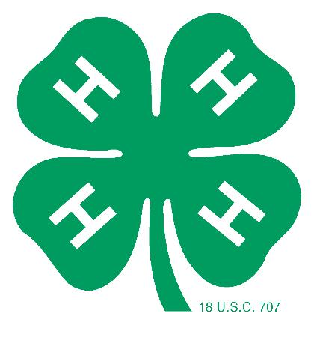

LOOK INSIDE FOR…..

- Junior Dairy Show
- Area Animal Science Days
- Project Learning Day
- Cloverbud Day
- Robotics Day
- Science Wednesday
- WI State Fair
- County Fair Face to Face Judging
- County Fair Information
- Horse Bowl Team Qualifies for Nationals!

This newsletter was mailed on May 27.

The Extension Office has a new address
303 W. Chapel,
Suite 1200
Dodgeville, WI 53533

Phone: 608-930-9850
Fax: 608-930-1220

http://iowa/uwex.edu

JUNE
1 County Fair Swine ID Forms Due
2 Equine Board Meeting
4 Dairy Breakfast, Fairgrounds
5,12,19,26 Livestock Judging – Location & Time TBA
6,13,20,27 Dog Project Practices & Meetings, Fairgrounds 6:30 pm
10 Child Development Meeting, HHS Building, 9-noon
11 Spring Preview/Southern Show, Jefferson
12 Ambassador Meeting 1:30, HHS Building
12-14 Badger Dairy Camp, Madison
14 Clothing Preview, HHS Building, 6:30 p.m.
17-19 Livestock Show Camp, Milwaukee
18 State Fair Dairy Show/Picnic, Fairgrounds
20-22 4-H Camp – Upham Woods
22 Area Animal Sciences Day, Beaver Dam
23 State Fair Exhibitor Meeting, HHSB, 6:30 & 8 p.m.
23 State Fair Entries Due
23 Cloverbud Day Camp, Fairgrounds, 9 am to 3 pm
27-30 WI 4-H & Youth Conference, Madison
27 Leaders Association, HHS Building, 7 p.m.
29 MAQA, HHS Building, 1 & 7 p.m.
30 Area Animal Sciences Day, Tomah

JULY
5 MAQA, HHS Building, 1 & & 7 p.m.
6 State 4-H Plant Science Day
7 Equine Board Meeting
7 Cattlemen’s Steak Feed, Trelay Farms, Livingston
10 Farmer’s Appreciation Day
11,18, 25 Dog Project Practices & Meetings, Fairgrounds 6:30 pm
20 Ambassador Banquet, HHS Building
21 MAQA, HHS Building, 1 & & 7 p.m.
23 Project Learning Day II, Fairgrounds
25 - 28 SWEL Trip to South Dakota
26 Robotics Day, HHS Building, 9am – 3 pm
27 Science Wednesday, HHS Building, 9 am – 3 pm
31 Shooting Sports, Fairgrounds, 6:30 pm

4-H INTERN

Summer greetings Iowa County 4-H families!!!

My name is Melissa Doyle and I am extremely excited to serve as this summer’s Iowa County 4-H Intern. I know I’ve got a busy summer ahead of me, but I’m really looking forward to meeting and working with all of you throughout these next three months!

I just graduated from the University of Wisconsin – Madison, where I double majored in Agricultural and Applied Economics and Life Sciences Communications. In the fall, I plan on continuing my education at UW-Madison as a graduate student. Throughout my college years, I was very active in many agricultural based organizations and held numerous internship positions. This past year, I interned at the Wisconsin 4-H Foundation, where I helped promote 4-H and raise funds for the 100,000 youth members that participate in the Wisconsin 4-H program.

It feels great to be back in my home community, as I was once an active Iowa County 4-Her myself!
I was a member of the Jonesdale Jays 4-H Club for 14 years and was involved in various projects such as sheep, swine, photography, foods, leadership, flowers, and many more! I also had the honor of serving as the 2006 Iowa County 4-H Queen, 2009 Iowa County Fairest of the Fair, and the Vice President of the Wisconsin 4-H Youth Leader Council.

4-H has truly played an important role in my life. It has opened so many doors and allowed me to grow as leader. I have had the chance to interact with tons of wonderful people and have made friendships and memories that will last forever. 4-H is a world of endless opportunities and has definitely helped make me the person I am today!

This summer I will be busy traveling to 4-H camp, chaperoning trips, attending 4-H meetings and events, brainstorming new and exciting ideas to incorporate into the 4-H program, working with youth and families of all ages, and tons more! I will be working alongside Deb Ivey and other Extension Agents in the UW-Extension Office. If you ever have any questions, comments, or concerns regarding the 4-H program, please don’t hesitate to stop by the office and see me. Feel free to email me at uwintern@iowacounty.org, or call me at (608)930-9850.

I am looking forward to a fun-filled summer and can’t wait to begin working with you!

See you all soon,

Melissa Doyle
2011 Iowa County 4-H Intern

NEWS FOR FAMILIES AND LEADERS
LEADERS' ASSOCIATION The next meeting will be held on Monday, June 27th at 7 pm in the HHS Center. Agenda Items: Raffle Ticket distribution, Recognition Plans, Plans for the Iowa County Fair, and other important issues


IOWA COUNTY DAIRY BREAKFAST –
Mark your calendars for June 4! The Iowa County Dairy Breakfast will be held at the Iowa County Fairgrounds. Cost is $6 for adults and $3 for children ages 10-3, children under 3 are free. Breakfast is served from 6:30 a.m. to 11:30 am. Come and enjoy scrambled eggs, sausage, pancakes, cottage cheese, ice cream sundaes, yogurt, milk and coffee.

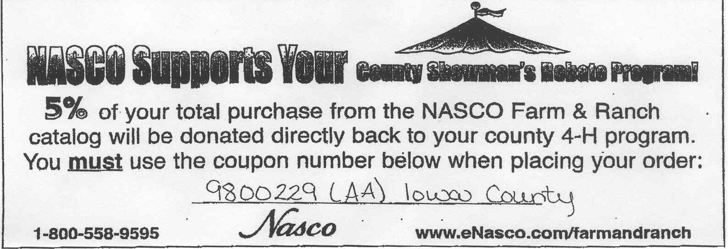
NASCO REBATE PROGRAM
NASCO will return 5% of your total purchases directly back to our county 4-H program. Just mention this coupon number when you place your order, or write the number in the billing information of your order form, or in the comments box of your on-line order. The Iowa County 4-H number is 9800229 (AA) Iowa County.

ANNUAL STEAK FEED
Mark your calendars for July 7th! The Iowa County Cattlemen’s Association Annual Steak Feed will be held at Biddick Trelay Farm, 2361 State Road 80, Livingston.

DROP BOX at Health & Human Service Center – If you need to drop any information off for the UW-Extension Office after hours, leave it in the drop box that is located at the front of the building by the flagpole. The box is checked each morning.

2012 Farmer's Appreciation Photo Competition

Vertical Photos taken in Iowa County will be used as a background photo for the 2012 Farmer Appreciation Day Celebration Advertisement. Photos should depict Agriculture in Iowa County.
Deadline is October 1, 2011. Must be 19 years or younger to participate.For information please contact Sue Judd judd@mhtc.net or 608-279-0131

IOWA COUNTY 4-H RAFFLE: Need some cash or a load of gravel? Look for packets of raffle tickets for 4-H Clubs to be distributed at your next 4-H club meeting. The top prizes this year include gift certificate for a load of gravel from Ivey Construction, cash prizes and many others. Last year there were over 300 prizes given away! 4-H clubs and the 4-H Leaders Association uses the funds raised from the raffle to support 4-H programs all year long.
CLUB NEWS
The meeting of the Rewey Lucky Stars was held on May 8 at 7:00 p.m. We discussed planting a tree in memory of Roy Schambow. The Ice Cream Social will be held on June 18 at the Rewey Fire Station. Raffle prizes are going to be there. We are going to participate in the Livingston Parade on June 26th. Come prepared with ideas for floats. Our next meeting is on June 12th at 7:00 p.m. Submitted By: Rachel Miller and Maranda McCarthy

Pleasant View 4-H Club will be holding a fundraiser at the Pizza Hut Buffet in Dodgeville on Monday, June 6th from 5 - 8 pm. A portion of buffet sales will be donated to the Pleasant View Club, so invite your friends and family to come out and eat at Pizza Hut to support the club!

REMEMBER June is Dairy Month! Start brainstorming those ideas for the 4-H Dairy Promotion Contest.
THANK YOU

Steve and Amy Barth, Gene Schriefer, Chase and Bruce Ivey, Jeff Thomas, Mike Robinson, Denny McGraw, Shari Grffunder, Eric Faull, Lora Liddicoat and Eric Johnannesen for helping idenifty swine and sheep for the county fair.

Thank you to those who helped at the Health and Human Services Building Open House: Katy and Robert Jinkins, Doreen Dochnahl, Jessica James, Debbie Heth, Chelsea May, Lynn Grunenwald

Thank you to Cummins Emissions and the Mineral Point Community Chest for donations to the 4-H Robotics program. Thank you to United Fund of Iowa County for a donation to the 4-H goat project.

CONGRATULATIONS

Congratulations to Taylor Fritsch for representing Wisconsin 4-H at the Public Issues Leadership Development conference in Washington, D. C.

Congratulations to Tony Weier, Dakota Thomas and Tabatha Faull for being awarded Iowa County HCE Scholarships.

Congratulations to Tayler Bowser, Macy Merwin, Carissa Tolzman, Marissa Grunenwald, Doreen Dochnahl, Lara Daentl, Emily James, Jessica James, Mallory Stanek, Jon Osterndorff, Sean Brown and Deb Ivey for walking in the Iowa County Relay for Life. They raised over $600 for the American Cancer Society!
PROJECT LEARNING DAY II
OLDER YOUTH

4-H Ambassador Team
Are you an older youth who would like to promote 4-H in the county and help out at special 4-H events? If so, the Ambassador program is for you. Any 2011-2012 high school freshman, sophomore, junior or senior Iowa County 4-H member may apply. There is no limit on the number of Ambassadors a 4-H club may have and you may be an Ambassador for as many years as you want – even if you are named King or Queen. All applicants will interview as part of the selection process. The Finale announcing all the members of the Ambassador Team and the King, Queen and 4-H Team will be held on Wednesday, July 20th at the Health and Human Services Building in Dodgeville. The Application forms are available in the Extension Office or www.iowa.uwex.edu and are due on July 6. Please notice, If you wish to be King, Queen, or a member of the 4-H Team that there is a separate application and an adult recommendation required for consideration.


Blue Ribbon Sale of Champions Foundation SCHOLARSHIP Four $1000 scholarships, four $750 scholarships and six $500 scholarships will be awarded to individuals between the ages of 17-19 as of January 1st of the current year who are current or past junior livestock exhibitors of beef, sheep, and/or swine at the Wisconsin State Fair. To apply, complete and return a Blue Ribbon Sale of Champions Foundation Scholarship Application, by June 15, 2011 to: Blue Ribbon Sale of Champions Foundation Scholarship, c/o WI State Fair Park Foundation, 640 South 84th Street, Milwaukee, WI 53214-0990. All scholarship winners will be recognized at the Governor’s Blue Ribbon Livestock Auction on Wednesday, August 10, 2011.
older youth

The scholarship application is available on the Iowa County UWEX page: http://iowa.uwex.edu

2011 Master Stockman Award applications will be accepted at both the Spring Preview and Summer Spectacular Shows. Three $750.00 Master Stockman scholarship recipients within the beef, sheep and swine species will be chosen as well as (3) $500.00 runner-ups. Entry information and applications can be found on the WLBA website at http://www.wisconsinlivestockbreeders.com/masterstockman.html or by contacting Executive Director Jill Alf at 608/868-2505 or alfhamp@centurytel.net.

camp opportunities

OPERATION MILITARY KIDS - If you’ve ever wanted to spend time outdoors, have a campfire, go swimming, use technology in the woods, shoot a bow and arrow, share your talents, use a compass or GPS, make new friends and memories to last a lifetime, then this is the experience for you!
If you are a member of a military family, you already qualify! Those youth who have experienced a deployment will have priority.

Youth grades 6 - 9 can participate in a 4 day, 3 night camp experience August 17 - 20.
Youth grades 3 - 5 have the opportunity to participate in a 3 day, 2 night camp August 21 - 23.
See the registration form at the back of this newsletter.

4-H GATEWAY ACADEMY – HAVE FUN WITH ENGINEERING AND SCIENCE!
Iowa county youth currently in 5th, 6th or 7th grade are eligible to enroll in the 4-H Gateway Academy, a one week day camp that includes hands on activities related to science, engineering and technology. The 2011 4-H Gateway Academies will be held at Platteville High School from June 20- June 24 and at Iowa-Grant High School from June 27-July 1 and at River Valley Middle School from July 11-14 and July 18-21. If you have questions, contact Deb at the Extension office at 930-9850 or debra.ivey@ces.uwex.edu

ROBOTICS DAY CAMP will be held from 9 am to 3 pm on Tuesday, July 26 at the Health and Human Services Building in Dodgeville. Design and build a LEGO Mindstorms NXT robot and learn how to program it to do specific tasks. There will be lots of hands-on activities and learning about 21st century workforce skills. There is a limit of 10 youth so register today using the registration form at the end of the newsletter.

SCIENCE WEDNESDAY will be held from 9 am to 3 pm on Wednesday, July 27 at the Health and Human Services Building in Dodgeville. Practice fun and interesting science, technology, engineering and math activities and experiments that will impress your family and friends. There is a limit of 10 youth so register today using the registration form at the end of the newsletter.

HOME AND FAMILY

Clothing Preview - The Iowa County 4-H Clothing Preview is set for Tuesday evening, June 14 at the new Iowa County Health & Human Services Center, 303 W. Chapel Street, in Dodgeville. Check-in will begin at 5:30 p.m. and judging will start at 6:00 p.m. (The times may need to be adjusted a bit depending on the number of participants.) We will conclude the evening with the announcement of special award winners.

Child Development Project Meeting – Kids & Safety
4-Hers in the Child Development project are invited to a Kids & Safety project lesson on Friday, June 10 from 9 am – noon. We’ll be meeting at the Health & Human Services Building in Dodgeville. The topics we are planning include: bike safety, car seat safety, “spot the tot”, animal safety, fire safety, choking, and safe sleep. We will also be learning about sugar in beverages and making some healthy snacks. Our speakers include staff from the Iowa County Health Department, Family Resource Center and UW-Extension. This project lesson will be great for 4-Hers who are caring for brothers & sisters or babysitting for others and even just for your own knowledge and awareness. BONUS – if you are thinking about possible county fair entries for your Child Development project, you’ll get LOTS of ideas at this project lesson!

Please register for this project lesson by Wednesday, June 8 by calling Muffy at 930-9850 or by e-mailing her at muffy.swingen@iowacounty.org

Hope to see you here!

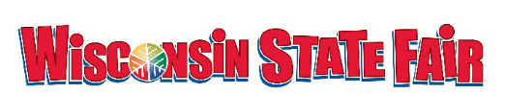

STATE FAIR INFORMATION AND ENTRIES
State Fair registration books and forms are available in the Extension Office and on-line at http://www.wistatefair.com/fair_competitions/junior_livestock.html. JUNIOR SHOW ENTRY FORMS ARE DUE TO THE EXTENSION OFFICE ON JUNE 23.

Everyone planning to exhibit in the Junior Show at the 2011 Wisconsin State Fair MUST attend the State Fair Orientation meeting on Thursday, June 23 at the HHS Building. Beef, Sheep, Swine and Goat Exhibitors will meet at 6:30pm. Dairy Exhibitors will meet at 8:00 pm. Completed entries will be collected at this meeting.

IOWA COUNTY FAIR

Fair books will be mailed in June. There have been changes to several departments so read carefully and return your entries by August 1!

FAIR SET-UP: Sunday, August 28th starting at 6:30 pm. at the fairgrounds. Volunteers from all 4-H clubs and FFA chapters are invited to help, but the following clubs are assigned to help with set up:
Blue Ribbon Clyde Go Getters County Line Country Cardinals Five Point Pleasant View Rewey Lucky Stars Rockwell Mills

FAIR CLEAN –UP – Tuesday, September 6 starting at 6:30 p.m. at the fairgrounds. Volunteers from all 4-H clubs and FFA chapters are invited to help, but the following clubs are assigned to help with clean up:
Bloomfield Buddies Cobb Busy Badgers Coon Rock
Jonesdale Jays Kountry Kousins Up and Over
Mounds View Section Line

DOG SHOWS: Obedience and Showmanship, Saturday, August 20, Fairgrounds
Agility, Thursday, September 1, 4:30 pm, Fairgrounds

HORSE SHOW: Monday, September 5, 9 am, Fairgrounds

MODEL HORSE SHOW: Thursday, August 18th at Health and Human Services Building from 5-9 p.m. in the Community Room. Judging will start at 5:00 p.m.; you can start to set-up at 4:00 p.m.

Youth Fair Board
If you are interested in joining the Junior Fair Board, contact Paula Rider at 608-341-7395 or paula.rider@landsend.com

Potted Plant
4-H Clubs and FFAs are encouraged to enter a potted plant at the Fair. The potted plants are to be in a base at least 16 inches high and 20 inches wide. Clubs can be as creative as they want for the type of pot, plants, and ways to display their club name and how to get their club involved. These pots will be displayed outside on the Fairgrounds during the Fair. They will be given a ribbon and a premium.

FACE TO FACE JUDGING EXPERIENCE
Youth who exhibit in Department 24 Mechanical Sciences - Class D Robotics, Class E Scale Models (including dioramas-farm displays), and Department 18, Cultural Arts- Class A, B, C, D and E--Leather, Department 18, Class G –Ceramics, Department 18, Class H – Theater Arts, Department 31, Class A, B, C, D, E—Communications, Department 33, Class A, B—Youth Leadership, Design Your Own Project, and Department 34, Class A, B, C, D—Health and Social Sciences will have face-to-face judging at this year’s Iowa County Fair. This judging will take place on Monday, August 29 at the Fairgrounds. Youth should report to the Youth Building at the Fairgrounds with their entries anytime between 12:30 pm and 6:00 pm on August 29. Exhibitors will meet individually with the judge and discuss their entries. If you are setting up a diorama, you can set it up anytime after 11 am and then have the judge review it beginning at 12:30 PM. Exhibits will remain at Fair until Monday, September 5th.

IT’S ALMOST FAIR SEASON!
- Iowa County Fair books will be mailed in mid-June. Entry forms will be included in the fairbook. In order to exhibit in a project area at the Iowa County Fair, 4-H members must be enrolled in that 4-H project. Junior fair entries are due on August 1 to Elaine Buening.
- It is the exhibitor’s responsibility to learn about the deadlines, workshops, activities, and requirements necessary for exhibiting in any project area.
- All 4-H members are encouraged to exhibit at and be involved in the Iowa County Fair. Limit exhibits to those entries that can be successfully completed by the scheduled judging day. Remember that school resumes about the time the fair starts.
- Clothing Preview, Foods Revue and Model Horse judging are held before the fair. Clothing Preview and Model Horse exhibits must be brought to the fair for display or they will not receive premiums.
- All county fair exhibits must be current work. This means the exhibit has been prepared between October of 2010 and August of 2011.
- Be sure to read and follow the rules in the fair book for each project that you plan to exhibit in. These rules explain how many entries you can have per project, what size displays are to be, where to attach tags, what additional information is needed, etc. Failure to follow these guidelines may result in disqualification or a lower placing. Be sure to read the Animal Health Regulations as well as the General Rules and Regulations for All Exhibitors in the front of the premium book.
- Parents may guide their children’s project work and encourage completion of project entries. Seek additional advice from project leaders, general leaders, friends, and 4-H project literature. Ask someone if the directions or requirements are not clear.
- Exhibitors will be allowed to sell one (1) animal—large or small. For example, 1 meat poultry OR 1 beef steer OR 1 pig OR 1 goat, OR Cheese, etc. Dairy will still select the top 6 dairy animals for the sale.

- ALL exhibitors selling in the auction will attend one educational program and notify the Extension Office prior to August 1. This applies to those selling poultry, rabbits, beef, swine, sheep, goats, and cheese (top 6 dairy animals.) ONLY identified educational programs will apply.
- Fair superintendents are adult and youth volunteers who work with youth and adult exhibits at the Iowa County Fair. But many volunteers are needed for the fair to operate successfully. Helpers are needed to assist at judging day, to set up displays, to work with special activities, and to supervise the building. Let Deb, Melissa or Muffy know if you want to help.

SHOOTING SPORTS

Shooting Sports meetings will be held in July and August as noted below. Members must attend a minimum of three meetings (at least one in August) to participate in the shoot at the County Fair. There is a $5.00 fee for materials.
IOWA COUNTY FAIR

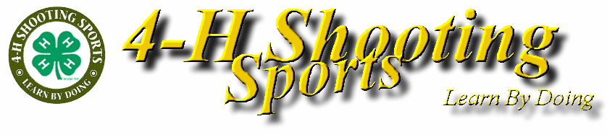
Summer -- Sunday nights 6:30 - 8:00 pm
July 31, August 7, 14, 21
Please contact Doug or Robin Digman at 935-2304 for further information.
MAQA

The Meat Animal Quality Assurance program (MAQA) is a Wisconsin-developed program that teaches quality assurance practices to Swine, Beef, and Sheep project members. The MAQA program fulfills the Pork Quality Assurance requirements. Anyone who plans on showing market hogs at Iowa County or Wisconsin State Fair MUST be MAQA certified. The Extension Office will offer MAQA certification from 1-3 pm and 7 -9 pm on Wednesday, June 29, Tuesday, July 5, and Thursday, July 21. All swine exhibitors who need to be certified or re-certified need to attend one of these MAQA programs in order to exhibit at the fair. MAQA also qualifies as an educational program for the Livestock Auction.

Swine project members in grades 3-13 will need to be certified in MAQA every year. However, youth who are in the intermediate age group (age 12-14, grades 6-8) or the advanced age group (ages 15-18, grades 9-13) have the option to “test out.” The test will be offered one hour before each MAQA session. Youth who plan to “test out” must pre-register with the Extension Office. The “Test Out” does NOT qualify as an educational program. Contact Deb for more information about the “test out” option.

AREA ANIMAL SCIENCE DAY

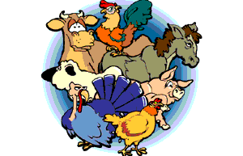
The Iowa County Dairy and Horse Judging teams will be participating at the Area Animal Science Day on Wednesday, June 22 in Beaver Dam at the Dodge County Fairgrounds. Contact Greg Stumpf, Jason James or Cheryl Hartman for specific information on practices and requirements. The Iowa County Livestock Judging team will be participating at the Area Animal Science Day on Thursday, June 30 in Tomah at the Monroe County Fairgrounds. Contact Jeff Thomas with questions.

Youth have many opportunities to participate at Area Animal Sciences Day:
- DAIRY Dairy Judging and Dairy Showmanship—if interested call Greg Stumpf or Jason James.
- LIVESTOCK Livestock Judging—contact Jeff Thomas at 574-7265 if interested.
- HORSE Horse Events for members enrolled in the Horse project include Horse Judging, & Hippology. If you are interested in Horse Judging, contact Cheryl Hartman at 574-4245.
- DAIRY & HORSE POSTERS Size: 14 in. x 22 in. Dairy posters should illustrate a dairy slogan. Horse posters can present any horse related topic.
- Small Animals—some activities are offered at each site. Contact Deb for more information.

HORSES

EQUINE BOARD MEETINGS The 4-H Equine Board meets on the first Thursday of each month at 7:30 p.m. Youth in the Horse Project, parents and leaders are invited to attend these meetings.

2011 4-H Horse Handbook For the latest information on state wide events and programs, check out this link: http://www.uwex.edu/ces/4h/onlinpro/HorseHandbook.cfm

OPEN RIDE TIME AT THE FAIRGROUNDS
Do you need time to ride your horse to practice for the Fair or would you like some time to just ride your horse? Join Sue Brunett at the Fairgrounds every Thursday starting May 26 through August 25 from 6:00 to 8 pm for an ‘Open Ride” for youth in the 4-H Horse project. This is on a drop-in basis, no need to call, simply show up with the following.......

* original coggins paper for each horse you bring
* boots, helmet and jeans
* a parent, older sibling or other adult to keep an eye on you while you ride
* cones or other props you may need to help you practice a particular skill

DRILL TEAM NEWS
Drill Team practices will start on Thursday, July 14 at 6 pm at the fairgrounds. Practices will be held each Sunday and Thursday night until the competition sometime in late August. The Drill Team will also present a demonstration at the 4-H Horse Show on Monday, Sept 5 at the Fairgrounds. Call Sue with questions at 987-4531.

WOW! What an exciting State 4-H Horse Bowl competition the Iowa County 4-H teams had on Saturday, May 7, 2011 at the UW-Marathon-Wausau Campus.

The 5 member Senior Team consisted of Carly Haack, Taylor Colin, Emily Wood, Brenna Ramsden, Beth Wood, and Kelly Ramsden. The team placed 4th out of 16 teams competing which qualified the team to participate in The Quarter Horse Congress Horse Bowl competition on October 11, 2011 in Columbus Ohio.

The first Junior Team consisted of Natalia Rudesil, Melissa Wood, Jenna Haack and Emma Puskala. The Junior Team also placed 4th out of 24 teams. The second Junior Team consisted of Hanna Rudesill, Faith Smart, Jade Smart, Ashley Degenhardt and Zoey French. They did a fantastic job!

Carly Haack and Faith Smart received Top Ten placing in Hippology.

The coaches are Brenda Degenhardt, Cheryl Hartman, Gene Schriefer and Lorrie Schriefer. A big THANK YOU to Iowa County Extension, Iowa County 4-H Leaders Association, Iowa County Equine 4-H Board and to all the parents for their support from September through May 7, 2011.
Congratulations to all.
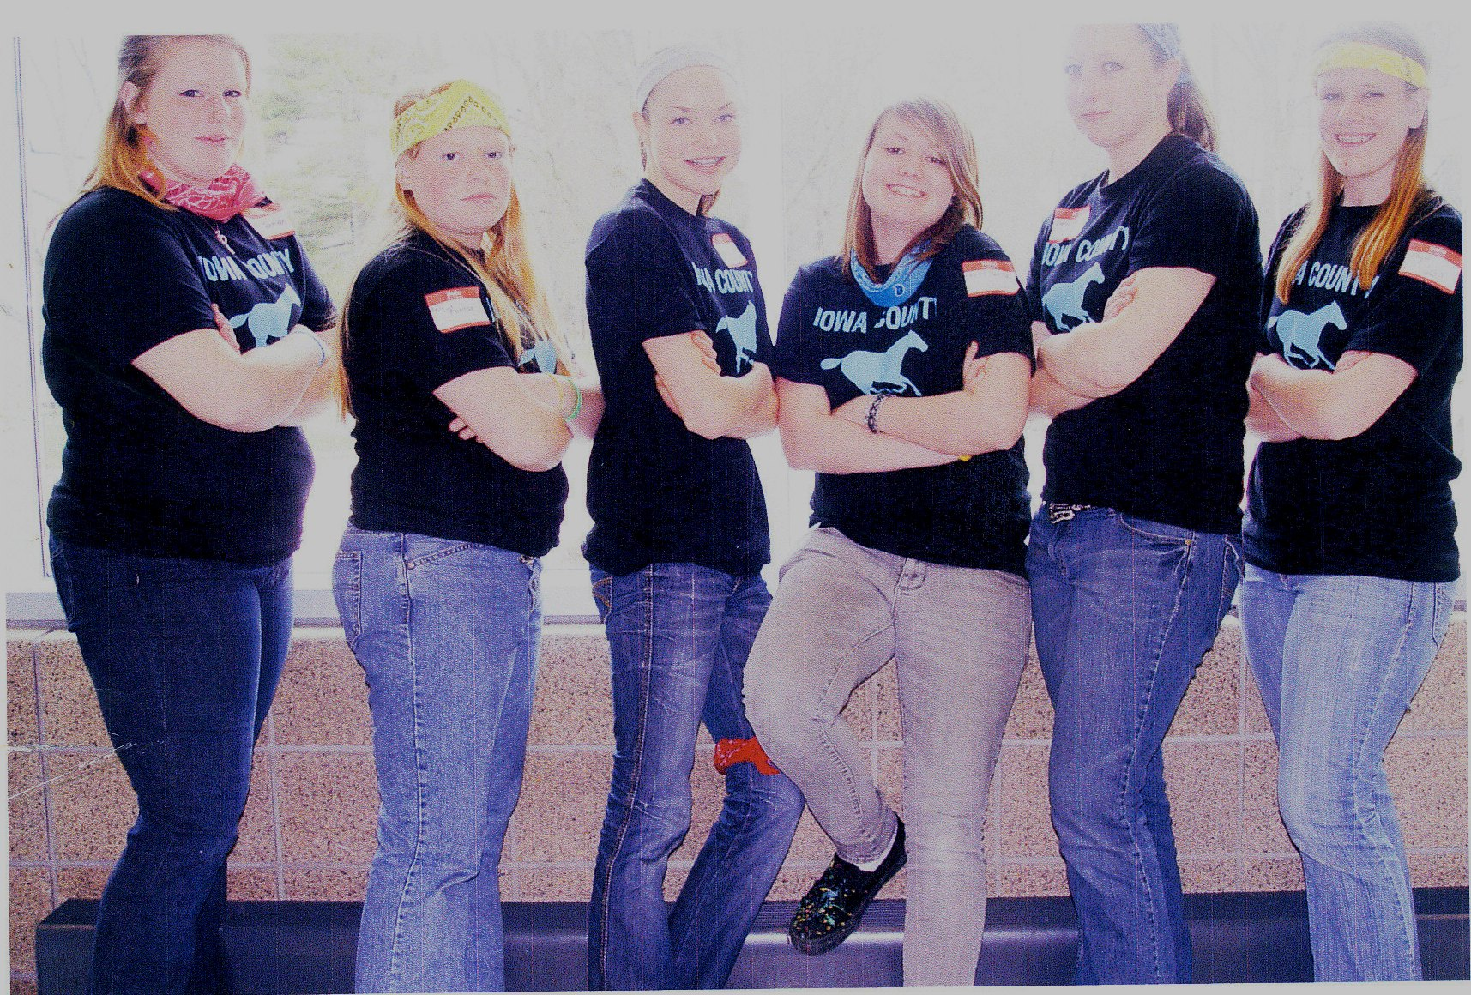
BELOW: Junior Horse Bowl members, left to right and bottom to top:
Jenna Haack
Melissa Wood
Jade Smart
Hannah Rudesill
Zoey French
Ashley Degenhardt
Faith Smart
Brenda Degenhardt
Natalia Rudesill
Emma Puskala
Lorrie Schriefer

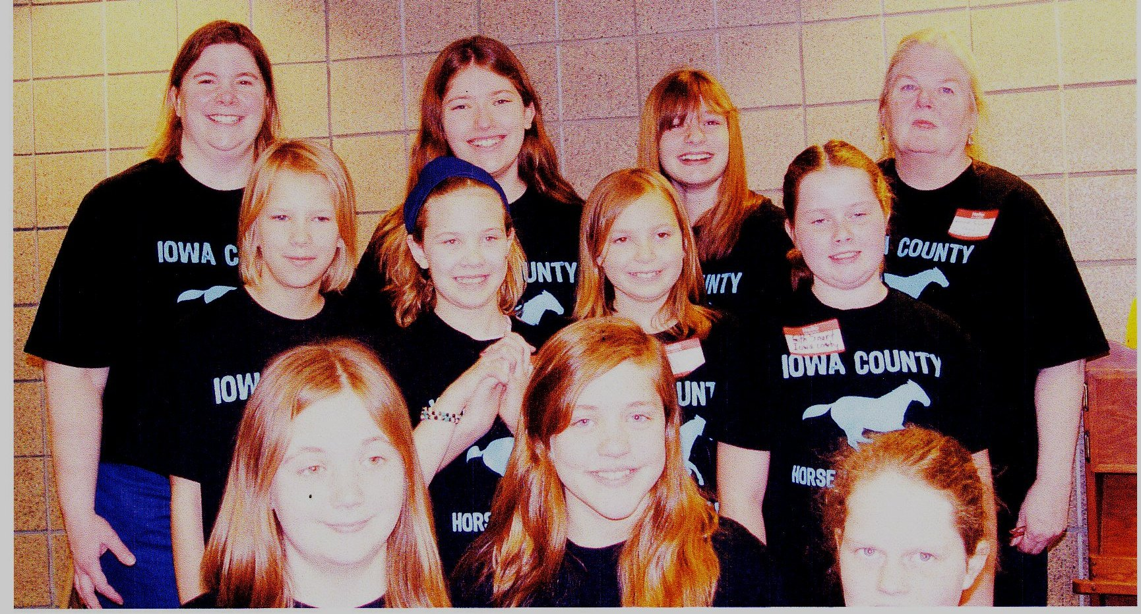
ABOVE: Senior Horse Bowl members (left to right):
Brenna Ramsden
Kelly Ramsden
Beth Wood
Carly Haack
Emily Wood
Taylor Colin

SMALL ANIMALS

Rabbits

IOWA COUNTY RABBIT ACHIEVEMENT PROGRAM: Rabbit Project members please consider participation in this exciting county-wide program: Participants must show a standard breed and follow all ARBA standards. Winner is the highest point earner by the county fair. Points must be accumulated with the same rabbit. Youth accumulate points by attending shows, competing in showmanship, attending project meetings, volunteer work, exhibiting at the county fair, placings at the county fair in class and in showmanship, and judging at the county fair. *Winner will be awarded the Rabbit Achievement Program Grand Champion Prize. For more information contact Pam Pishion @ 935- 3601 or Lisa Swenson @ 523-1443
Rabbit project meetings are held at 4 pm on the last Sunday of every month except May and September at Pam Pishion’s (5031 Leffler Road, Dodgeville). Contact Pam Pishion @ 935- 3601 or Lisa Swenson @ 523-1443 or lisaswenny@hotmail.com for more information.

Dogs

4-H Dog Project Members: If you have questions about the dog project, contact Karolyn or Matt Levin at 924-9609 or Vicki Hugill at 623-2660.

Dog project training classes start Monday June 6, 2011 at 6:30 pm at the Iowa County Fairgrounds. Bring a copy of your vaccination record to the first training session - your vet will be happy to provide you another copy.

◄ All 4-H dogs must be vaccinated for distemper, hepatitis, leptospirosis bortella (kennel cough) and parvovirus, prior to attending any training classes. We will accept vaccinations done by an experienced pet owner/handler if accompanied by a copy of the sticker from the original vial with the vaccination lot # and expiration date.

◄ Rabies vaccinations MUST BE given by and the certificate signed by a licensed, accredited veterinarian.

◄ A 4-H dog may not attend training sessions, clinics or exhibit if showing signs of communicable diseases, or internal or external parasites.

If any dog project member is interested in training and showing an Iowa County Humane Society dog through our partnership together, please let Karolyn and Matt Levin know by calling 608-604-3375.

Get these dates on your calendar!

2011 State 4-H Agility Show—August 6 at the Sheboygan County Fairgrounds, Plymouth

2011 State 4-H Dog Obedience and Showmanship Show—Labor Day Weekend, Washington County, West Bend

Elroy Fair Invitational Dog Show-Obedience, Showmanship, and Agility - June 26 at The Elroy Fair, Elroy, WI Contact: Jackie Menn, lawnviewfarm@yahoo.com or 608-823-7640

Fennimore School Fair - Dog Show - Obedience, Showmanship and Agility - August 26, 2011 Contact the Fennimore School (608-822-3245) for a school fair book

Blake's Prairie Fair in Bloomington- Dog Agility Show - Saturday, July 23, 2011
Contact Jessica Cliff at 608-413-0838 for a fair book

STATE 4-H PLANT SCIENCE DAY

Wednesday July 6, Waushara Co. Fairgrounds, Wautoma WI
A fun way to learn about Horticulture Science!! Plan now to participate in the State 4-H Plant Science Day event to be helped at the Waushara Co. Fairgrounds. Youth in grades 3 - 13 can test their knowledge about plants while learning how to judge and identify a wide variety of plant specimens. Youth can also compete in photography and speaking contests. See the Horticulture Contest Study Manual (2002) which can be found online from the National Junior Horticulture Association (NJHA.org). The contest for participants will be held in the morning, and the afternoon will provide educational workshops for all. The event begins with registration at 9:30 am and ends at 2 pm. Cost is $10 and includes all materials, handouts, and lunch. Pre-registration is preferred for lunch and materials count. Registration deadline is June 17. Call Extension office at 930-9850 for more information.

DAIRY

IMPORTANT INFORMATION FOR STATE FAIR DAIRY EXHIBITORS
To exhibit at the 2011 Wisconsin State Fair, youth must be 12 years of age on January 1, 2011 and a member of 4-H, FFA or a junior breed organization. To show Dairy cattle at State Fair, these rules must be followed:
- Ownership deadline is January 1, 2011 for all dairy cattle two years and older. New clarification: Registration papers must show exhibitor recorded as owner or co-owned with immediate junior family members only. Immediate junior family members must be under 21 years of age as of January 1st of the current Fair year. Immediate junior family members include siblings (brother or sister) and step- siblings (step-brother or sister). Animals co-owned with parents, the family farm or others are considered managerial.
- Calves and yearling ownership/co-ownership deadline will continue to be May 31st.

The State Fair Dairy Show is scheduled for Saturday, June 18 at the Fairgrounds. Registration information is at the end of the newsletter. The registration form and entry fee are due to Extension Office by June 10th.

LIVESTOCK

LIVESTOCK JUDGING TEAM PRACTICE
Practice will be held on Sunday June 5th at Jeff Thomas’ Farm at 6:00. Future practices will be held on Sunday, June 12, Sunday June 19, and Sunday June 26, locations to be determined. Watch for a postcard or email with locations as the dates get closer. Call Jeff at 574-7265 with questions.

EDUCATIONAL PROGRAM REQUIREMENT TO PARTICIPATE IN THE COUNTY FAIR AUCTION

ALL exhibitors selling in the auction will attend one educational program and notify the Extension Office prior to August 1. This applies to those selling poultry, rabbits, beef, swine, sheep, goats, and cheese (top 6 Dairy animals.) Below are educational programs that will apply to this requirement.

Project Learning Day II July 23—selected sessions
Livestock or Dairy Judging Team Practices May, June
MAQA Certification June 29, July 5, or July 21
Badger Dairy Camp June 12-14, UW-Madison campus
Youth Livestock Show Camp June 17-19, State Fairgrounds, West Allis
County Project Meetings Summer, as scheduled

FFA Members remember that you are responsible to have your FFA Advisor notify the Extension Office if you have completed any educational programs.

CLOVERBUD CORNER

.

June 23rd - Cloverbud Day Camp at the Iowa County Fair Grounds. There is a registration form is on the next page. The focus will be on Animals and will include all the fun and activities of previous years.

July 23rd- Project Learning Day at the Fairgrounds Don’t forget to sign up for special Cloverbud sessions. Registration information is at the back of the newsletter.

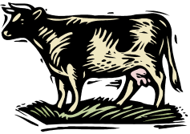
Cloverbud Day Camp
Iowa County 4-H Cloverbud Day Camp

THURSDAY June 23rd
Drop off 9 a.m. Pick up 3 p.m.

Iowa County Fair Grounds, Mineral Point

Camp Cost: $10

Register by: June 15th

The Cloverbud Day Camp is designed for youth enrolled in Cloverbuds. This camp is also open to 3rd graders. Activities planned for the day include a visit with animals, an art and crafts session, games and recreation, & music and singing. Lunch will be provided, as well as a morning and afternoon snack.

Transportation: Parents are responsible for getting the kids to and from the Iowa County Fair Grounds.

*Please remember to bring weather appropriate clothing, sunscreen, bug spray, and water (optional).

4-H CLOVERBUD DAY CAMP
Registration Due: June 15th

Name

Address

4-H Club

Phone

Parent Signature

Return to UW-Extension Iowa County by June 15th with a check for $10 made payable to Iowa County 4-H Leaders.

Robotics Day Camp and Science Wednesday


Robotics Day Camp
Tuesday, July 26
9 am to 3 pm

Science Wednesday
Wednesday, July 27
9 am to 3 pm

Both camps will be held at the Health and Human Services
Building in Dodgeville.

Camp Cost: $10 for each camp; this includes lunch and snacks

Register by: July 18
Limited to 10 Youth per camp

The Robotics Day Camp is designed for youth in grades 5 and above. Youth will design and build a LEGO Mindstorms NXT robot and learn how to program it to do specific tasks. There will be lots of hands-on activities and learning about 21st century workforce skills.

Science Wednesday is designed for youth in grades 3 – 8. Youth will practice fun and interesting science, technology, engineering and math activities and experiments that will impress family and friends.

4-H ROBOTICS DAY CAMP AND SCIENCE WEDNESDAY
Registration Due: July 18

I plan to attend ____________Robotics Day Camp __________Science Wednesday

Name

Address

4-H Club

Phone

Parent Signature

Return to UW-Extension Iowa County by July 18 with a check for $10 for each camp the youth plans to attend. Make the check payable to Iowa County 4-H Leaders.

IOWA COUNTYJUNIOR DAIRY SHOW AND PICNIC

The Iowa County Junior Dairy Show and Picnic is scheduled for Saturday, June 18 at the Iowa County Fairgrounds. THE SHOW WILL BEGIN AT 9 a.m. Only registered cattle may be shown at this event since this is the show that selects the participants for the State Fair. If you wish to exhibit dairy cattle at the Wisconsin State Fair Junior Show, you must exhibit at this Iowa County show.
All youth are encouraged to participate in this show even if you do not plan to attend State Fair. Younger members will learn new skills and older members will renew friendships and fine-tune their skills.

Please note these rules:

1. Youth who exhibit must be current members of a youth organization, i.e., 4-H Junior Dairy Association, Junior Breed Association, FFA, etc.

2. Your animal must be at the fairgrounds by 8:30 a.m. Judging will begin at 9 a.m. and should be completed about noon.

3. You must have your animal’s registration, health and/or vaccination papers with you on show day. Contact the Extension Office or check with your veterinarian about health requirements for your animals. If you do not have the proper papers, you will not be able to show.

4. Plan to join the family day and picnic that follows the show. Bring a couple dishes to pass and your own utensils and plates. The Holstein Association will furnish milk. There will be a meeting after the lunch to select animals/exhibitors for State Fair.

5. All animals will be judged blue, red and white.

6. To be eligible for State Fair you must:
a. Be at least 12 and not over 19 as of Jan. 1, 2011.
b. Own your own project animal by January 1, 2011 if 2 years or over. A State Fair exhibitor may show one managerial animal (calf or yearling). Registration and managerial papers must be in order on show day.

7. Contact the Extension Office one week before the show if you are unable to show your animal yourself.

8. All exhibitors are responsible for cleaning all stalls before leaving the grounds.

There is an entry fee of $2 per animal to cover expenses. There is a $5 entry fee per animal for late entries after June 10th.

Return the registration form and entry fee to Extension Office by June 10th.

Registration for Junior Dairy Show and Picnic
Iowa County Fairgrounds, June 18

Name(s) ________

4-H Club/FFA Chapter/Breed Organization

Age as of Jan. 1, 2011

Registration
Name of Animal Number Breed Birthdate Owned or
Managerial

____________ ____________

____________ ____________

____________ ____________

____________ ____________

Entry fee of $2 per animal shown is payable by June 11th. Late Entries are $5 per animal. Registration papers need to be in order by day of show. This show is open to all exhibitors enrolled in 4-H, FFA, Junior Holstein Association. Return this registration form to UW-Extension Office, 303 West Chapel Street, Ste. 1200, Dodgeville, WI 53533 by June 10th.

Operation Military Kids Super Summer Camp Spectacular

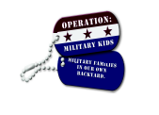
REGISTRATION
DUE JULY 15, 2011

Camper name ____________ ;______ Grade___ Gender___

Parent name __________________________________________ Cell phone __________________

E-mail _____________________________ Home phone___ _

Address ____________________

Branch of Military _____ I currently participate in 4-H _____Yes _____No
T-shirt size: Youth S M L XL Adult S M L XL

I would like to be in a cabin with

List any special dietary needs

** If necessary, please indicate below what accommodations your child would need, and for which activities:

Parent Signature _________________________________________ Date: ____________

Return by July 15 with $10 payment to:
(checks made payable to UW Extension)
OMK Summer Camp
Richland County UW-Extension
1000 Highway 14 West, Richland Center, WI 53581

Confirmation materials, including a packing list, will be mailed no later than early August.

All activities are supervised by Upham Woods staff, counselors, OMK Super Summer Camp Spectacular takes place at Upham Woods, just outside of Wisconsin Dells. The main lodge, nature center, craft barn and swimming and fishing area are located at the base of a hill. The cabins are located at the top of a steep hill with a separate shower/bath area. All water activities take place on the Wisconsin River. Youth are assigned to cabins by gender and age. Each cabin includes counselors. If your child needs accommodations to fully participate in any part of the camping experience, please indicate on the registration form below. We want each child who attends to enjoy the experience!

IOWA COUNTY UNIVERSITY EXTENSION
NON-PROFIT
U.S. POSTAGE
PAID
Dodgeville WI 53533
Permit No. 65

303 West Chapel Street
Dodgeville WI 53533



Requests for reasonable accommodations for disabilities
or limitations should be made prior to the date of the
program or activity for which it is needed. Please do ADDRESS SERVICE REQUESTED
so as early as possible prior to the program or activity
so that proper arrangements can be made. Requests are
kept confidential.

4-H…….Taking the Lead
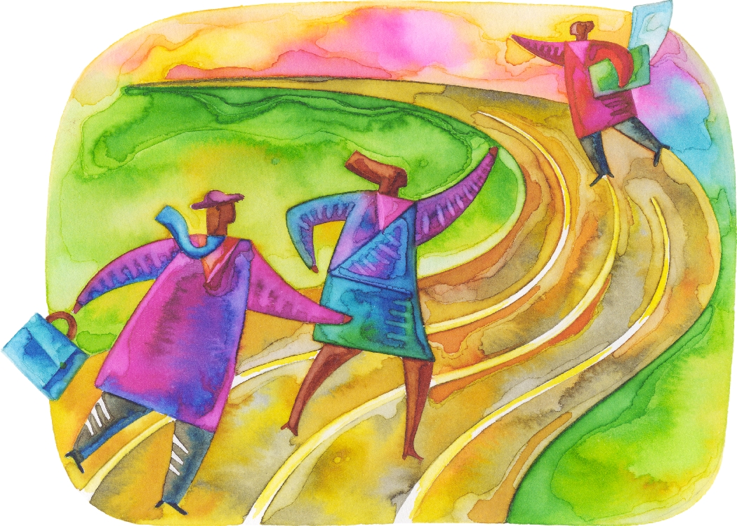

An EEO Affirmative Action employer, the University of Wisconsin-Extension provides equal opportunities in
employment and programming including Title IX and ADA requirements. Persons with disabilities who require alternative means for communication of program information should contact the UW-Extension Office at 608 930-9850

THE CLOVER CONNECTION
IOWA COUNTY 4-H FAMILY NEWSLETTER

IOWA COUNTY 4-H LEADERS COUNCIL UNIVERSITY of WISCONSIN EXTENSION
President – Lynn Grunenwald – 2013 303 W. Chapel Street
Vice President – Shelly Osterndorff -2012 Dodgeville WI 53533
Secretary – Carissa Tolzman - 2012 Phone (608) 930-9850
Treasurer – Bill Mitchell – FB Rep FAX (608) 930-1220
Directors: Muffy Swingen - 2013
Deidra Culp - 2012 Deb Ivey, 4-H Youth Development Agent
Clare Wiesbrook - 2011 Melissa Doyler, 4-H Intern
Sara Aide – 2011 Ruth Schriefer, Family Living Agent
Youth – Jon Osterndorff, Amber Wagner, Paul Ohlrogge, Community Resource
Tayler Bowser, Marissa Grunenwald-2012 Development Agent
Youth Leaders Council Rep – Taylor Fritsch Gene Schriefer, Agriculture Agent
Donna Peterson, Nutrition Program Coordinator
Julie Stephenson, Nutrition Educator
Muffy Swingen, Department Assistant
Register for 4-H programs by fax or e-mail:
FAX: 930-1220 http://iowa.uwex.edu/4h
E-mail: Office Hours Monday through Friday, 8:30 a.m. to 4:30 p.m.
debra.ivey@ces.uwex.edu
There is also a phone with voice mail available nights and weekends. http://www.uwex.edu/ces/cty/iowa TTY Relay System 711

