2015-2016 Iowa County 4-H Ambassador Information
Applications due July 8, 2015

WHO CAN APPLY?
Any Iowa County 4-H member in grades 9th-13th who completed their 2014 4-H Record Book.

WHAT DO YOU DO?
- Promote 4-H throughout the county
- Assist in leading 4-H activities and events
- Develop teamwork, leadership, and other important life skills
- Communicate with the public and serve as public relations ambassadors
- Lead community service projects at the club and county levels
- Work with other youth from around the county
- Have fun and represent Iowa County 4-H

EXPECTATIONS:
- Participate in at least 5 4-H Ambassador activities
- Help at 3 events during the Iowa County Fair
- Attend at least 75% of the Ambassador meetings
- Assist at county 4-H events
- Proudly promote 4-H

HOW TO APPLY:
- Complete the 4-H Ambassador Application.
- Have an adult sign your application.
- If you are interested in serving as 4-H Royalty or on the “H” Team, complete the additional questions and submit 2 recommendations.
- Return the application to the UW-Extension office by July 8, 2015.

CRITERIA FOR 4-H ROYALTY AND “H” TEAM
- Have at least one year of experience as a 4-H Ambassador
- Serve as a leader and role model for fellow Ambassadors
- Help coordinate and lead Ambassador meetings, committees, programs, etc.
- Represent Iowa County 4-H at community activities and events

INTERVIEWS
All applicants will be interviewed on Monday, July 20th. The newly selected 4-H Ambassador Team, 4-H Royalty, and “H” Team will be announced at the annual 4-H Ambassador Banquet that evening at the Health and Human Services Building in Dodgeville.

If you have any questions, please contact Melissa Doyle, Iowa County 4-H Youth Development Advisor, at melissa.doyle@ces.uwex.edu or (608) 930-9850.
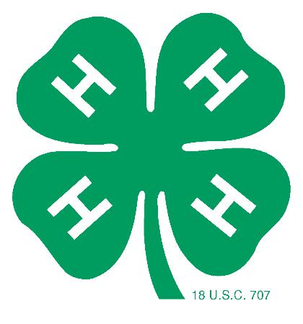

IOWA COUNTY 4-H AMBASSADOR APPLICATION

Name:

Name of Parents/Guardians:

4-H Club: Years in 4-H:

Grade Completed: Future Plans:

- Why do you want to be a 4-H Ambassador?

- Briefly explain what qualifies you to be a 4-H Ambassador? How will these qualifications assist you in your Ambassador responsibilities?

- 4-H Project Overview
List your primary 4-H project involvement, the number of years you’ve been enrolled in the project, and any special achievements or honors you have received.

Project Years Enrolled in Project Project Achievements/Honors

- 4-H Leadership/Citizenship Experience
Briefly highlight your 4-H experience in the following areas:

4-H Club & County Leadership (officer roles, committees, programs, etc.)

4-H Club & County Participation (activities, events, trips, etc.)

4-H Club & County Citizenship/Community Service Involvement

I personally have prepared this application and certify that it accurately reflects my work. If selected to serve as a 4-H Ambassador, 4-H Royalty, or on the “H” Team, I fully understand my responsibilities and am committed to fulfilling them.

Applicant’s Signature: ______________________________________________________________ Date: _________________________

To be completed by an ADULT who knows you (but is not related to you).

I support this young person’s application to be an Iowa County 4-H Ambassador. I understand that he or she will represent and promote Iowa County 4-H throughout the year. This youth demonstrates good character, teamwork, dependability, leadership, and communication skills.

Adult Signature: _____________________________________________________________________ Date: _________________________

Interviews will be held on Monday, July 20th from 12:00pm-4:00pm. You will be notified by mail of your interview time. Please state your interview time preference: __________________________________________________.
We will try our best to accommodate your request, but cannot give any guarantee.

Return by July 8, 2015 to: UW-Extension Iowa County
Attn: Melissa Doyle
303 W Chapel Street
Dodgeville, WI 53533

IOWA COUNTY 4-H ROYALTY AND “H” TEAM APPLICATION

Name:

Name of Parents/Guardians:

4-H Club: Years in 4-H:

Grade Completed: Future Plans:

Have you previously served as the Iowa County 4-H King or Queen? Yes__________ No__________

Have you previously served as one of the four H’s on the “H” Team? Yes__________ No__________

- Explain what leadership qualities and values are significant to being a 4-H Ambassador.

- Why is the 4-H Ambassador program important to Iowa County 4-H?

- How have you contributed to the 4-H Ambassador program? What additional contributions will you make if selected to serve as the 4-H King/Queen or a member of the “H” Team?

Return this application along with two adult recommendations to the Extension Office by July 8, 2015.

Recommendations: One recommendation is needed from a 4-H leader and one recommendation is needed from another non-related adult. (Please do not add additional pages.)

Iowa County 4-H Royalty & “H” Team Recommendation

Name of Applicant: __________________________________________________________________________________________________

How long have you known the applicant? _________________________________________________________________________

Signature: ____________________________________________________________________________ Date: _________________________

In what capacity do you know the applicant? (Check all that apply)

4-H Leader________ Teacher________ Family Friend________ Neighbor________ Other________

- Describe the applicant’s involvement in 4-H or in other organizations/activities.

- How has the applicant demonstrated leadership and teamwork skills?

- Comment on the applicant’s dependability, character, and attitude.

Please return recommendation by July 8, 2015 to: UW-Extension Iowa County
Attn: Melissa Doyle
303 W Chapel Street
Dodgeville, WI 53533

